Company Profile

Name YOUTECH COPORATION CO., LTD.

Business Address 304 Phaholyothin 87 Soi 6 Yak 3
Phaholyothin Rd., Prachathipat,
Thanyaburi, Pathumthani 12130
Telephone (+66) 2-9922933
Facimile (+66) 2-9922932

Managing Director Mr. Weera Saensap
Mobile Phone (+66) 89-8962204
E-mail weera.s@youtech.co.th

- Over 10 Years for SMT Equipments
and advance dispensing machine service manager
- Major support flip chip process,underfill,conformal coating ,porting and dispensing process advance training

Asst.Service Manager Mr.Amnart Noipho
Mobile Phone (+66) 89-8962204
E-mail amnart.n@youtech.co.th

- Over 10 Years for SMT Equipments
and advance dispensing machine service manager
- Major support flip chip process,underfill,conformal coating ,porting and dispensing process advance training.

Service Engineer
E-mail
Mobile Phone

Account Manager
E-mail
Mobile Phone

Sales Administrator
E-mail
Mobile Phone

Regular Business Hour MON-FRI 08.30am to 5.00pm

SAT-SUN OFF

Business Territory All Over Thailand

Business Description Sales Distributor For:

Electronic market section:
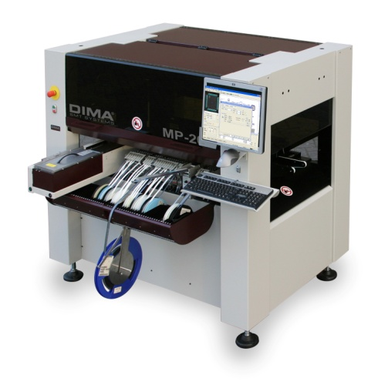
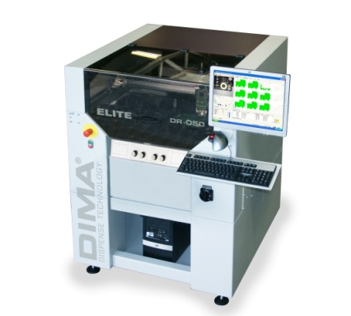
- DIMA
The complete solution for Potting or Dispensing of Dots or Lines, Glob Top and Under Fill or Conformal Coating and SMT product Pick & Place Equipment

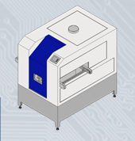

- INTERFLUX Products
Spray fluxer machine ,solder wire and chemicals

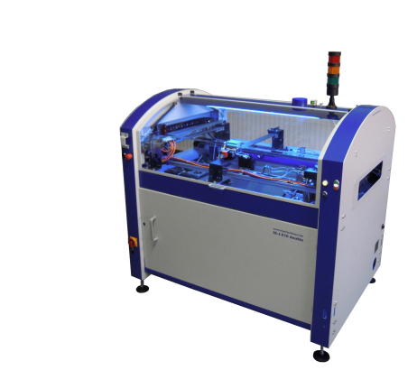

- INTERSELECT Products
Selective wave soldering machine

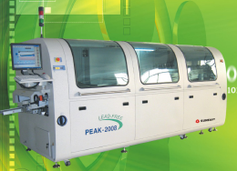
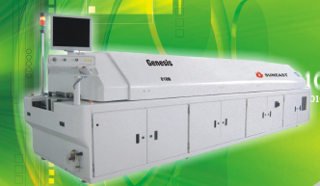

- Sun East Electronic Technology
Reflow and wave soldering machine

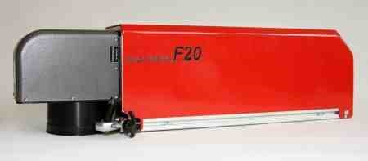
- SK Latronics Laser GmbH
Laser Products

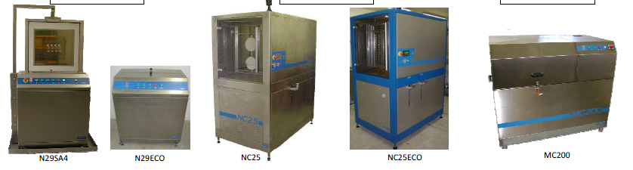

- MBtech Cleaning Equipment

Customer List
Electronic market section:

            - SVI PUBLIC CO.,LTD


            - FABRINET

            - KIMBALL
            - DELTA



            - CELESTICA
            - BENCHMARK
            - SAMINA-SCI



            - TRILITHIC-ASIA
            - FAGOR ELECTRONIC
            - TEAM PRECISION



            - FOCUZ
            - HANA
            - BELTON
            - INTEL
            - BLUECHIPS
            - CHERRYTECH





Bank Reference

TMB Bank
Muangaek-Rangsit (Branch)
304/2-4 Moo 13 Phaholyothin Rd., Kookot,
Lumlookka, Pathumthani 12130
ACC No.099-2-42463-0 (savings)
Swift Code: TMBKTHBK

Site Map

